**HW Assignment #1**Due Date:10/06/2019

In this assignment, you will create an Android application to display the following table on the screen.   
  
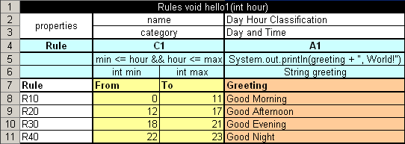

Please implement your application first with Java API and then with Layout Resource File.

**Submission**

Turn in the code for this homework by uploading your project to a public repository on GitHub. While you may discuss this homework assignment with other students, you must complete the work on your own.

To complete your submission, upload the below information to Titanium:

**Your name**

**Repository** https://github.com/ /